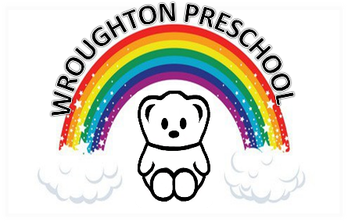
Wroughton Preschool
The Church Hall, Priors Hill,
Wroughton, Swindon, SN4 0RT
Registered Charity Number: 291748
Ofsted URN: 507874

Tel: 01793 812888 (general)
Tel: 01793 798000 (sessions)
wroughtonpreschool_enquiry@live.co.uk

2 Year Old Enrolment Form

If places are unavailable, your child will be placed on our waiting list and will be contacted when a place becomes available.

The fees for 2 year olds is £13.00 per session.

Monday to Friday
Please note that we are unable to accept 2 year olds for whole days (9am-3pm)
Morning session 9.00 am to 12.00 noon
Afternoon session 12.00 am to 3.00pm

Child’s Name
Date of Birth

Address

Telephone - home
Telephone - mobile
Email address:
Parent’s Name
Please tick your session preferences;
 | Mon | Tues | Wed | Thurs | Fri
AM
PM

A holding fee of £25 will be required once sessions have been agreed. This fee will be returned when your child starts at the Preschool or, if you tell us at least four weeks before the start date, that you no longer require the place. Should you decide you no longer need the place we will not retain the details on this form (See our Privacy Notice).

Wroughton Preschool may not be able to offer sessions to all names on the waiting list.
Sessions are subject to availability and completion of this form does not therefore guarantee a place.

Please note water bottles are available at a cost of £2.

Parent’s Signature:
Date:

