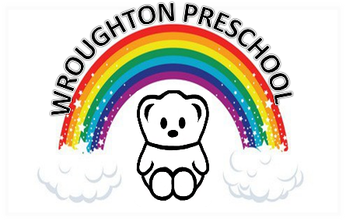 22nd March 2020

Dear parents and carers,

The preschool will be remaining closed until further notice. I will update you all as soon as I can confirm when we are allowed to re-open.

Please email me, at any time, if you have any queries or concerns over the coming weeks and I will do my best to help you.

Best wishes
Katie

