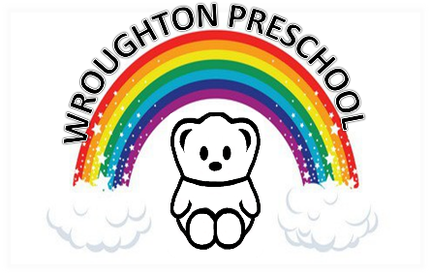 16th Marth 2020

Dear Parents and Carers,

Coronavirus (COVID-19)

Following the latest Government advice, we will be remaining open until further notice. However, these new procedures will now be in place with immediate effect:

- Please do not send your child to preschool if they have a new continuous cough and/or high temperature (over 37.8C). Children should stay at home for 7 days.
- If you need to come into preschool with your child, please ensure you use the hand sanitiser available at the door.
- If a significant number of staff become ill or self-isolate, we will contact all parents and carers again regarding the preschool remaining open.

The Department for Education has launched a new helpline to answer questions about Coronavirus (COVID-19). Staff and parents can contact the helpline as follows:
Phone 0800 046 8687
Email DfE.coronavirushelpline@education.gov.uk

We appreciate that these new measures may cause some inconvenience to parents, but during these uncertain times we must follow government advice, safeguard children and do everything we can to contain this disease.

Thank you.

Zena Warburton and Katie Woodcock
Wroughton Preschool

