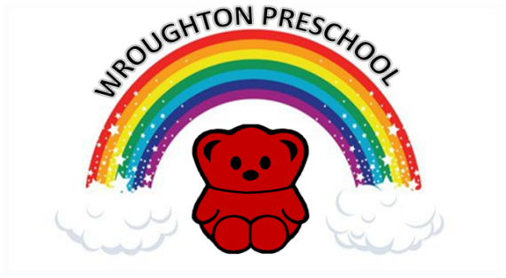

Parish Church Hall
Priors Hill
Wroughton
SWINDON
Wiltshire
SN4 0RT
Reg Charity No. 291748

January 2022

Dear Parents/Carers,

The committee would like to welcome you back to the first term of 2022!

The Christmas raffle was such a great success, and the proceeds will be used to buy some new outdoor equipment for the children.

We would love to continue this success. The children are invited to enjoy a pack of smarties that will be provided by the preschool and to fill the tube up with as many coins (or notes) as they can.

Parents/carers can use this opportunity to get their child to do chores and pay them with the coins that can be added to the tube.

All tubes are to be handed in once full and the last day for handing in to the preschool is Monday 31st January. Children are welcome to fill as many tubes as they can but only one tube will be provided by preschool.

We hope this fundraiser is a great success and lots of fun for all!

Thank you for your continued support.

Best wishes,

The Preschool Committee

wroughtonpreschool@gmail.com

